# Chapter I- Introduction

## 1.1 Background of study

The system is to make an online web application for the customer to make the purchase payment according. This project aimed to develop an online application for customer to purchase/buy the lab equipment. Customer can buy/purchase according to the product type.

## 1.2 Introduction of the Organization

Decode Genomics and Research Center Pvt. Ltd is a Molecular Diagnostic Laboratory providing molecular diagnostic services. It is located in Bagbazar, Kathmandu. It was established in 2015.

## 1.3 Current Situation of the Organization

In the current situation, DGRC works in a traditional way and they want to explore their business in e-commerce field as well.

## 1.4 Problem Statement of the report

DGRC Pvt. Ltd is mainly focused on Molecular Diagnostics services and selling lab equipment’s but the problem faced by the lab is they don’t have any online medium for selling their lab equipment’s and DGRC is missing out on customer by not entering on online medium. The way they sell their lab products in traditional way and old method of record keeping is which I considered as a problem in the lab.

The project will help the customer to purchase the equipment’s through online medium which helps customers to know about the details, availability and unavailability of the product. The customer now can directly buy the lab equipment from their remote place and won’t need to physically visit the lab and buy the equipment. The record keeping of the lab will be more organized as the details of each customer and product will be digitalized. This project will help DGRC to make their online business grow and help them understand the e-commerce side of the business.

1

## 1.5 Objectives of the Study

The system aims to help the customer to purchase the product online through the internet and track sales record and manage the products.

The main objectives of the study are given as follows:

* To build a web based application that manage DGRC.
* To sell and manage the product through online
* To keep payment record
* To gather more customer

## 1.6 Literature Review

The main objective of this study is to explore the growing demand for online marketplaces that connect buyers and sellers of laboratory equipment. The review emphasizes the benefits of such websites, including enhanced access to a wide range of instruments, cost-effectiveness, and improved resource utilization. The emergence of online platforms facilitating the buying and selling of laboratory equipment has transformed the way scientific instruments are acquired and utilized. This literature review delves into the significance of these websites in the research community and explores the benefits they offer to both buyers and sellers. The review also examines their impact on lab efficiency, cost-effectiveness, and sustainable resource management. Online lab equipment trading platforms provide researchers and institutions with convenient access to a wide array of laboratory instruments. This accessibility streamlines the procurement process and offers a diverse selection of equipment, enabling users to find the most suitable options for their specific needs. Such websites promote cost-effective equipment transactions by facilitating direct interactions between buyers and sellers. Eliminating intermediaries often leads to competitive pricing and cost savings for both parties, making essential lab equipment more affordable.

The literature supports the importance and advantages of online lab equipment trading platforms. These websites offer convenience, cost-effectiveness, and sustainability while fostering collaboration and research efficiency. As the scientific community continues to embrace digital solutions, these platforms play a crucial role in connecting buyers and sellers, ultimately contributing to advancements in scientific research and innovation.

## 1.7. Methodology

Methodology in terms of software development refers to the systematic and structured approach used by software development teams to design, build, test, and deliver software products or applications. It outlines the processes, practices, and guidelines that developers and project stakeholders follow to ensure the successful and efficient completion of the software development project.

### 1.7.1 Data and Information

Primary method of data collected was used for gathering information. The organizational visit was administered to the Director of DGRC, and there was a positive response from the director in terms of questions related to the project.

### 1.7.2 Project Framework

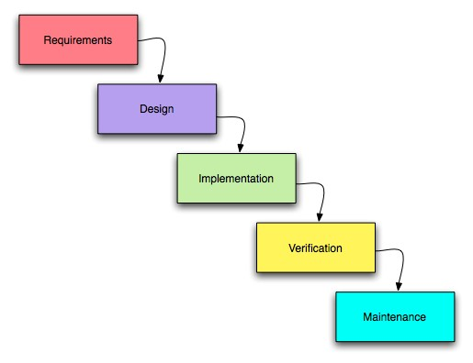

*Fig 1.1: Waterfall Model*

The reason behind considering this methodology is as follows:

* Every step and requirement is defined before design.
* Easier to understand and implement.
* No ambiguous requirement in development and implementation

### 1.7.3 Tools Used

Database: MySql

Language: HTML, CSS, PHP,JS

Server: Xampp

Text editor: Visual Studio Code

### 1.7.4 Technique of the project report

#### 1.7.4.1 Problem analysis

The main problem of DGRC is that they haven’t explored the online side of business and it can be a drawback to emerging business. The internet aspect is missing and it can be a major issue for the business.

#### 1.7.4.2 Feasibility analysis

The analysis of the project has led to the conclusion that the project is feasible with time and cost. The tools used for development are almost Open Source and involve less cost and maintenance

.

#### 1.7.4.3 Technical feasibility

The technical analysis will require you to thoroughly assess the proposed technical solution. Technical feasibility evaluates whether the proposed web-based application can be developed using the available technology stack and resources. I am using Visual Studio Code to develop the project.

#### 1.7.4.4 Operational feasibility

It assesses whether the e-commerce website can be effectively integrated and

operated without significant disruption or obstacles.

#### 1.7.4.5 Schedule feasibility

The analysis of this project has led to the conclusion that the project is feasible with time as it can be completed with the given time frame including all the criteria and the features.

|  |  |  |
| --- | --- | --- |
| **Task** |  | **Duration** |
| Project Planning | 1 week |  |
| Research Study | 2 week |  |
| Collecting Information | 2 weeks |  |
| Coding and Design | 4 weeks |  |
| Unit Testing | 3 weeks |  |
| Deployment | 1 weeks |  |

*Figure 1.2: Project Schedule*

# Chapter II- Task and Activities Performed

## 2.1 Analysis of tasks

Before analyzing the task, organization was visited to collect the requirements. After the requirement collection the major problem was identified and a procedure was carried out to build the working framework. The analysis of major problem was helpful in drawing out the conclusion and solving the issue. The newly developed system helps to solve the problem that is being faced.

## 2.2 Problem and issue

After the brief analysis of the task and requirement. I found out the root problem that the Lab was facing. The organization haven’t explored the online side of business and that is making them lack behind.

## 2.3 Analysis of Possible Solution

### 2.3.1 Requirement Analysis

The main objectives of requirement analysis are to identify and evaluate the requirement of the proposed system. It helps to know about user requirements, system requirements, functional requirements, and non- functional requirements for LEMS of DGRC. The primary goal of requirement analysis is to establish a clear and complete understanding of what the software should accomplish before proceeding with its design and development.

### 2.2.2 Functional Requirements

These requirements are typically described in a detailed and unambiguous manner to guide the development process. Functional requirements focus on what the system should do and how it should respond to various inputs and actions. They are essential for determining the core features and functionalities of the software system**.** Functional requirements should be measurable, meaning that they can be tested to ensure they are met**.** A functional requirement is a description of the service that the software must offer. It describes a software system or its components. A function is nothing but inputs to the software system, its behavior, and outputs. It describes the functions of a system and its components.

The LEMS for Decode Genomics And Research Center shall contain the admin who could be able to manage the product and its different categories. Functional requirements can be briefly described with the help of Use Case Diagram which is shown below:

2.3.2.1 Use Case Diagram

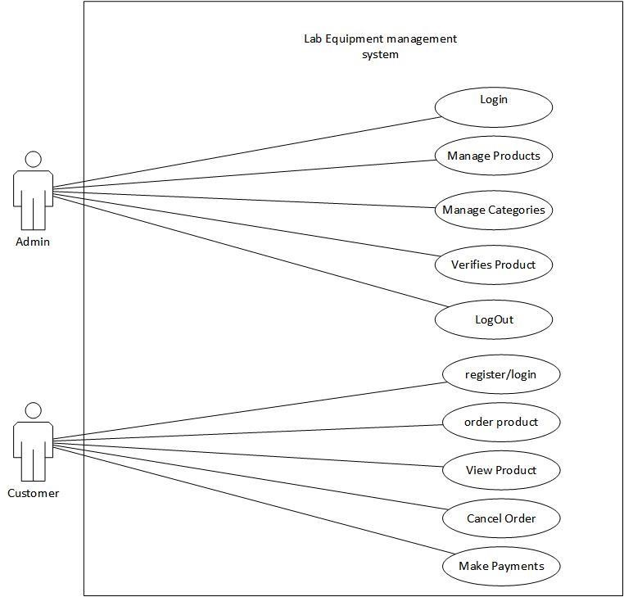

*Figure 2.1: Use Case Diagram of Lab Equipment Management System*

Table 1.1: Manage Product

|  |  |
| --- | --- |
| USE-CASE IDENTIFIER | UC-1: MANAGE PRODUCT |
| Primary Actor | Admin |
| Secondary Actor | None |
| Description | The admin can add, view, update, and delete the product. The admin and insert and view the categories. |
| Pre-condition | The admin have to be logged in to modify the product |
| Post-condition | The database is updated and product is modified. |
| Failure-scenario | The database is not updated |

Table 1.2: Manage categories

|  |  |
| --- | --- |
| USE-CASE IDENTIFIER | UC-2: MANAGE PRODUCT |
| Primary Actor | Admin |
| Secondary Actor | None |
| Description | The admin can Insert and View categories |
| Pre-condition | The admin have to be logged in to insert the categories |
| Post-condition | The database is updated categories are stored. |
| Failure-scenario | The database is not updated |

Table 1.3: View all payments

|  |  |
| --- | --- |
| USE-CASE IDENTIFIER | UC-3:VIEW ALL PAYMENTS |
| Primary Actor | Admin |
| Secondary Actor | None |
| Description | The admin can view all payments |
| Pre-condition | The admin have to be logged in to view the payments |
| Post-condition | Admin can get some reports based on payment |
| Failure-scenario | Failure in storing payment record |

Table 1.4: View product

|  |  |
| --- | --- |
| USE-CASE IDENTIFIER | UC-4: |
| Primary Actor | Customer |
| Secondary Actor | None |
| Description | Customer can view the product so that they can place the product for order |
| Pre-condition | Customer need to visit the website to be able to view the product |
| Post-condition | Customer will be able to place the order |
| Failure-scenario | The product details can be mismatched |

Table 1.5: Order Product

|  |  |
| --- | --- |
| USE-CASE IDENTIFIER | UC-5: |
| Primary Actor | Customer |
| Secondary Actor | None |
| Description | Customer can order the desired product |
| Pre-condition | Customer must be logged in to the system |
| Post-condition | Database is updated with new order |
| Failure-scenario | Difficulties in order placing due to lack of product in stock |

Table 1.6: Make Payment

|  |  |
| --- | --- |
| USE-CASE IDENTIFIER | UC-6: |
| Primary Actor | Customer |
| Secondary Actor | None |
| Description | Customer can make payment after placing the order via digital payment method |
| Pre-condition | Customer must be logged in to the system |
| Post-condition | The database will be updated with the payment information |
| Failure-scenario | Failure in payment due to technical error |

##### 2.3.3 Non Functional Requirement

Non-Functional Requirement specifies the quality attribute of a software system. They judge the software system based on responsiveness, usability, security, portability, and other non-functional standards that are critical to the success of the software system. The non-functional requirements for the project are as follows:

###### ● Security

The system implementation was done in JavaScript Programming language which has its own security system. The authorities are provided according to the roles. Validations are imposed to prevent any unauthorized access.

###### ● Safety

The project does not have any direct physical harm to the users. The project is safe to use as it gives data confidentiality, availability and authorization to all of its users.

###### ● Backup

The database may get crashed at any certain time due to operating system failure so it is required to take the database backup.

###### ● Performance

The system is expected to perform effectively and efficiently. It should be able to provide fast and optimal performance in a cost-effective way.

**2.3.4 Software Requirements:**

|  |  |
| --- | --- |
| IDE | Visual Studio Code |
| Design | Figma |
| Diagrams | draw.io, Microsoft Visio |
| Server | XAMPP, MySQLServer |
| Browser | Google Chrome, Mozilla Firefox, Edge |

*Table 2.1: Software Requirement*

**2.3.5 Hardware Requirements:**

|  |  |
| --- | --- |
| Operating System | Windows 10 |
| Processor | 2.13 Ghz |
| RAM | 8 GB |
| Disk Space | 4 GB minimum |
| Device | PC, Laptop, Android Device |

*Table 2.2: Hardware Requirement*

##### 2.3.6 Entity Relationship Diagram

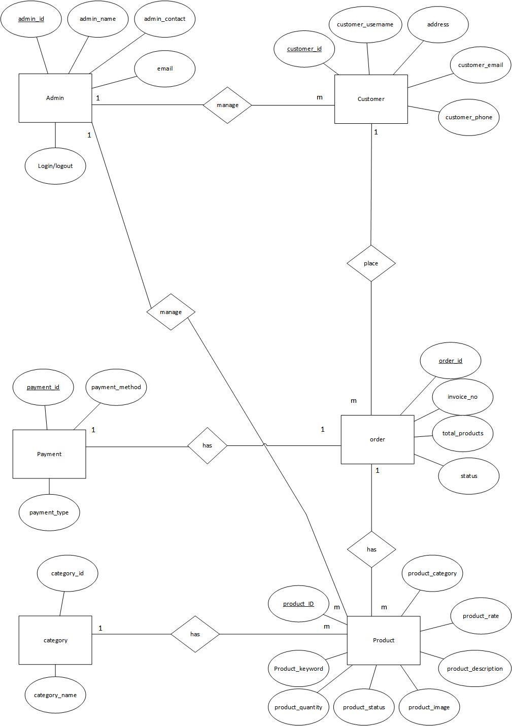

*Figure 2.2: Entity Relationship diagram of LEMS*

##### 2.3.7 Relational Model

Relational Model is conceptual basis of relational database (Somerville, 1. 2011). It is a UML diagram that shows a static view of a system. Relational Model is described in the figure which is shown below.

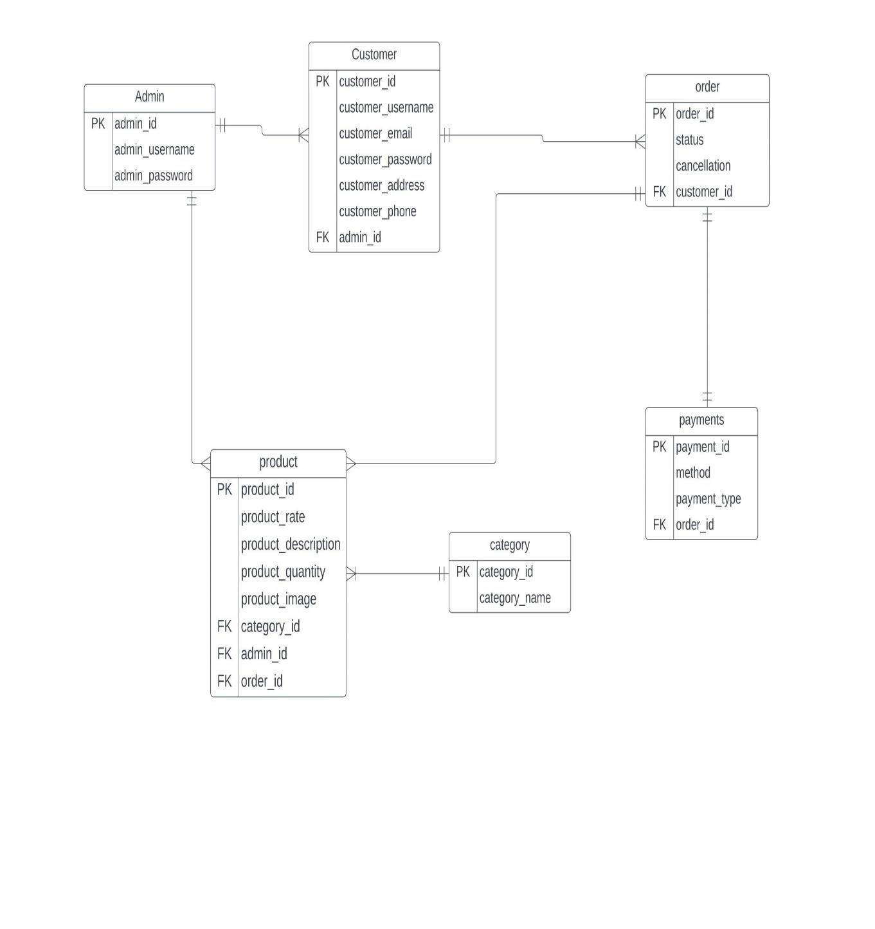

*Figure 2.3: Relational model of LEMS*

##### 2.3.8 Activity Diagram

* Manage Category

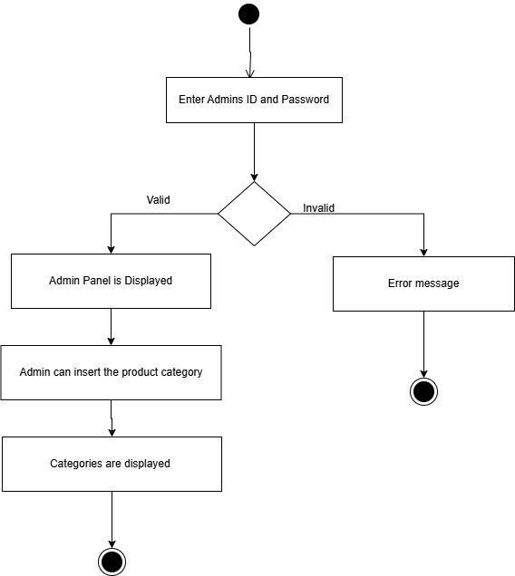

* View Product

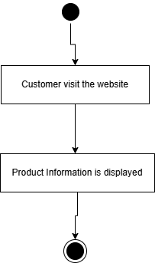

* Manage Product



* Order Product

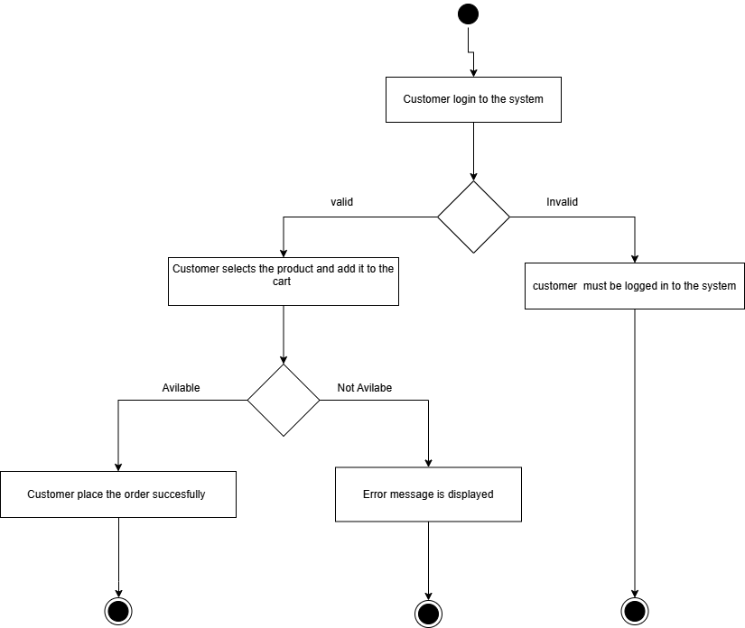

* Make Payment

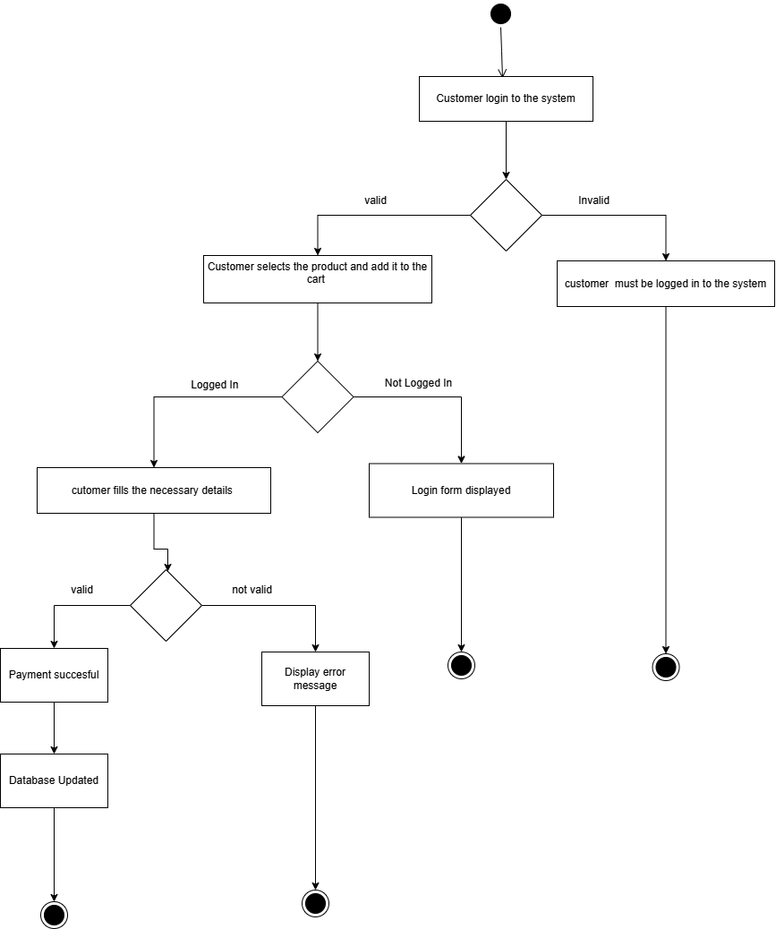

* Cancel Order

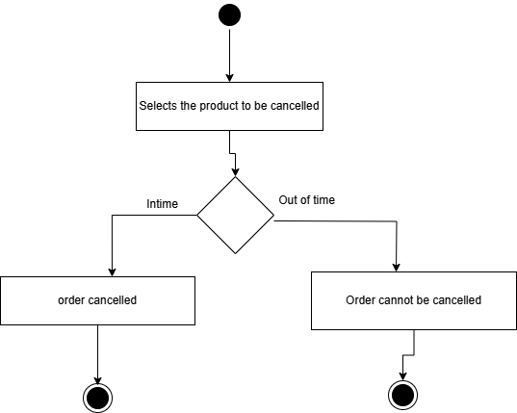

*Figure 2.4: Activity Diagram*

### 2.3.9 Testing

In testing, the different inputs were tested as input to GUI forms which can is shown below with the help of table as well as figure:

Testing Table for admin Login:

|  |  |  |  |  |
| --- | --- | --- | --- | --- |
| Unit effected | Test input data | Actual result | Expected result | Remarks |
| Admin Login | Username=admin2  Password=admin2 | Error:  “Login error message is displayed” | Logged in | Fail |

Testing table for registering a new user:

|  |  |  |  |  |
| --- | --- | --- | --- | --- |
| Unit effected | Test input data | Actual result | Expected result | Remarks |
| New user  Registration | Username=  Email=  Password=12  3  Phone=9821 634040  Address= ktm | Field username is empty  Field email is empty | Field username is empty  Field email is empty | Pass |

Testing table for inserting new category:

|  |  |  |  |  |
| --- | --- | --- | --- | --- |
| Unit effected | Test input data | Actual result | Expected result | Remarks |
| Inserting new category | Category name=’Blood pressure measurement’ | Category inserted | New Category should be updated | Pass |

## 2.4 Findings

After analyzing about the organization, I came to know that if organization uses the same traditional approaches to record about products, orders , payments and customer then it would increase the cost of products which directly impacts market today and customers may be distracted. If DGRC uses the application for the business purpose then it would be easier to meet the current demand and supply of the customer and thus the company would be able to meet its goal comfortably.

**.**

# Chapter III- Discussion and Conclusion

## 3.1 Discussion

The aim of this project was to research and develop a web-based application for

”DECODE GENOMICS AND RESEARCH CENTER” to increase their sales and

make an online presence. The project covers the problem that was identified during the organization visit and the solution to the problem was solved by developing software. The system will help for the every necessary activity to be done and for the working in the systematic way. The development is assumed to be very helpful for the organization

## 3.2 Conclusion

The development is able to fulfill the requirement of the organization by reducing the gap between the customer and the organization. After the collection of requirements we were able to build a web based application that allows the buying of lab equipment’s online. The system was successfully completed in time as per the objectives .The system is expected to fulfil all the requirements and prove to be beneficial for DGRC. Testing had been performed upon the system, its unit to ensure the normal behavior of the system. The waterfall model used in this system is helpful to check in every phase after each coding.

## 3.3 Future Enhancements

This project was started with the aim of making the online buying of lab equipment possible. The system was successfully built and is said to be kept updated with the resources available.

**References**

For reference website:

[Decode Lab & Genomics Research Center | Decode Lab (dgrc.com.np)](https://www.dgrc.com.np/) For coding help:

[Stack Overflow - Where Developers Learn, Share, & Build Careers](https://stackoverflow.com/)

For design and models: [draw.io (diagrams.net)](https://app.diagrams.net/)

For equipment information:

[Lab Equipment - Chemistry LibreTexts](https://chem.libretexts.org/Courses/Hope_College/General_Chemistry_Labs/Lab_Equipment)

# Appendices

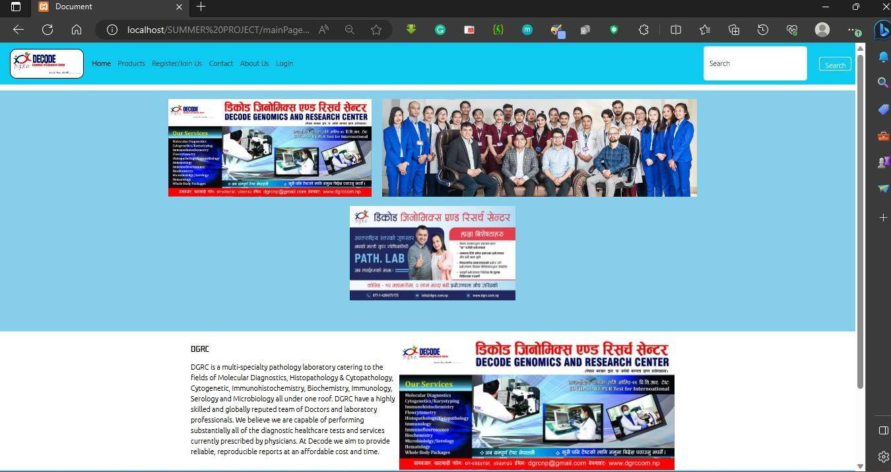

Home Page

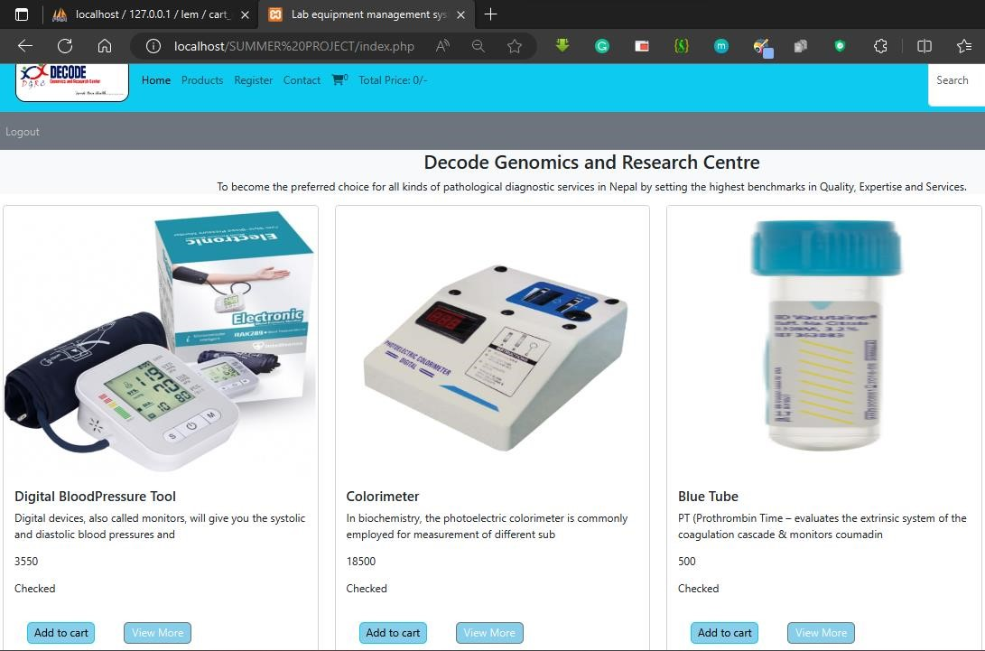

Product view

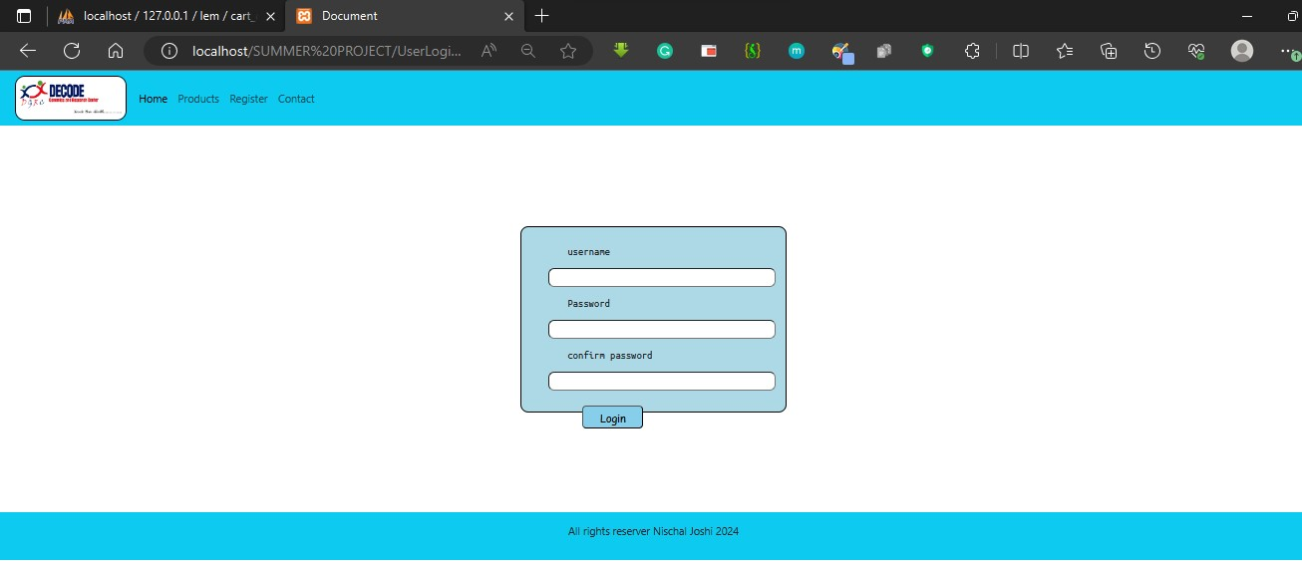

User Login

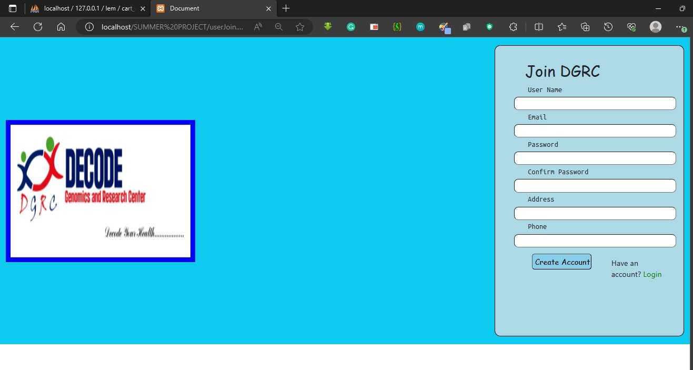

User Register

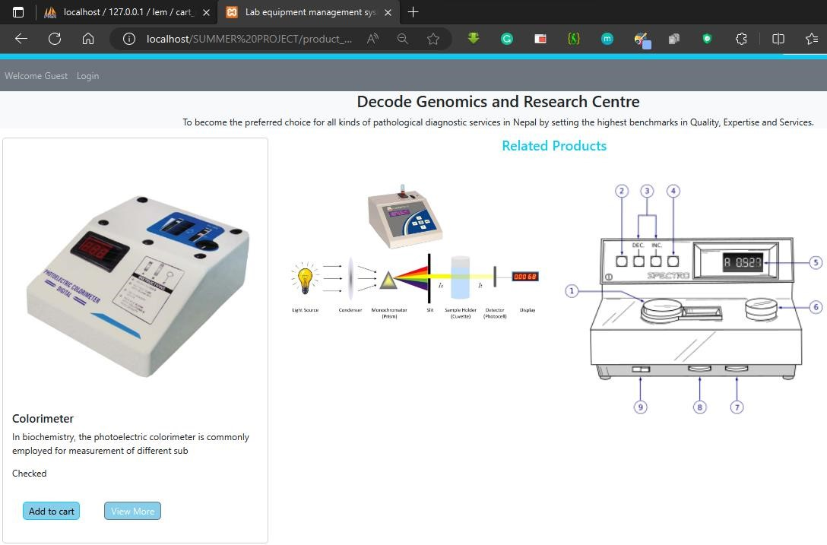

View Product Details

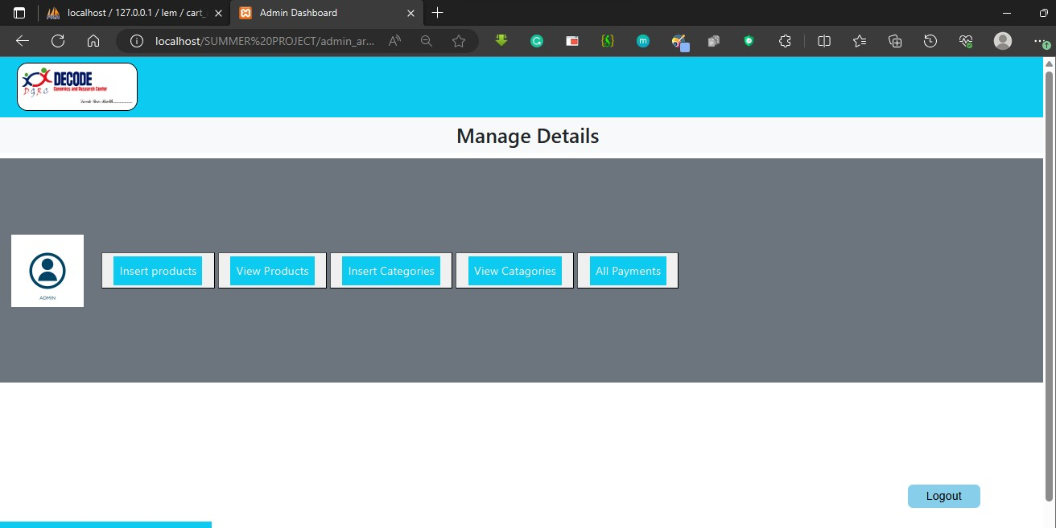

Admin Panel

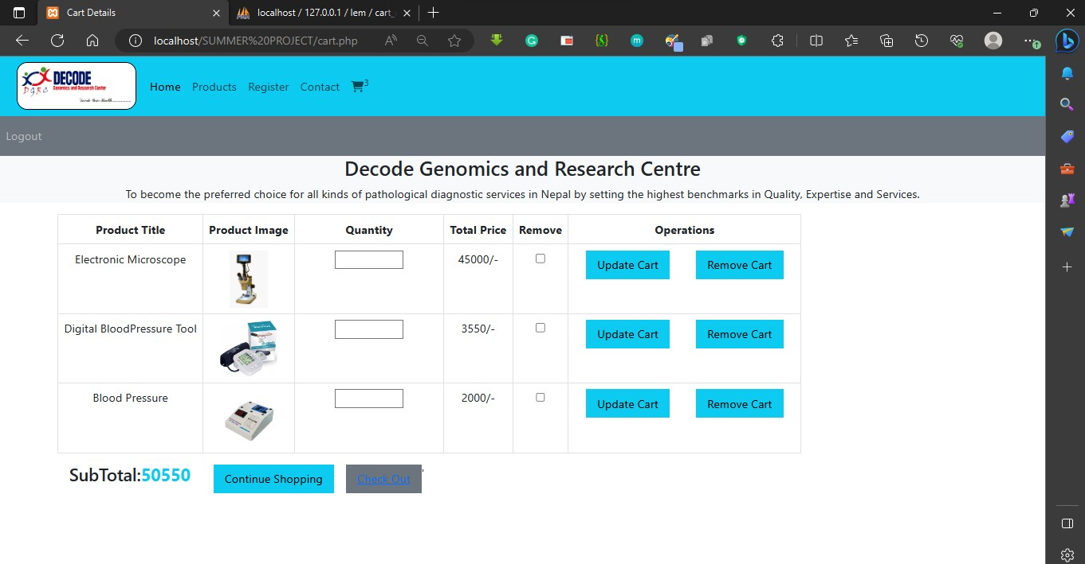

Add to Cart

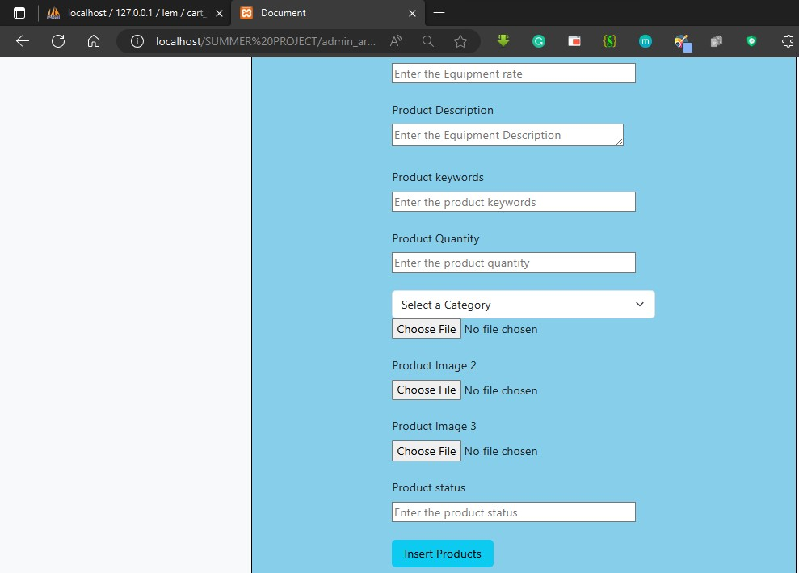

Insert Product

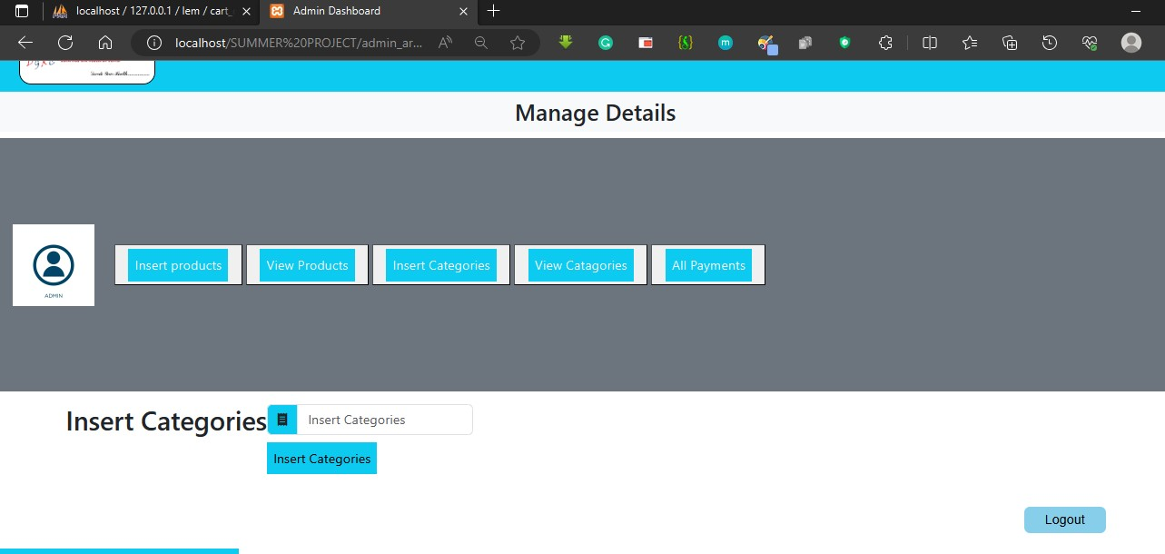

Insert Category

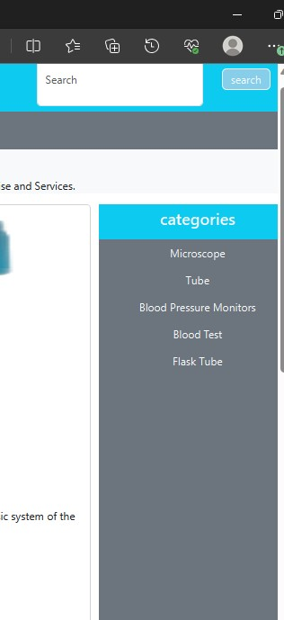

View Inserted Categories